**[16TH DEC 2014](http://myjourneytovalhalla.tumblr.com/post/105347765331/making-of-compositing)**

1.Backplate grading: I wanted to have it flat and with way more details before I did the final grading later on with everything integrated into the scene already.

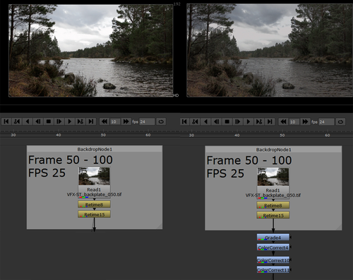

2. Multi pass compositing of the ship: On the picture I compare the beauty render with my multi pass compositing. I already colour corrected it for integration purposes. Because the sail was way too bright I made a roto, tracked it and used the mask for a grade node to get it darker. Normally it is easier because you render matte passes but I forgot it to do it so I had to feel the pain and do it by hand. I also reduced the reflections in general because I thought they are way too heavy. I merged my beauty render with the reflection pass with the blending mode “difference” and used the mix to set the intensity. It got me a quite good look like this.

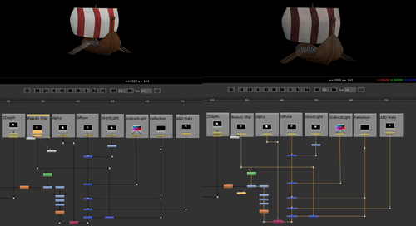

3. Fog and ship integration: To integrate the fog and the ship I used basically many grade, colour correct and roto nodes. I also added some blur and lightwrap to integrate the ship better.

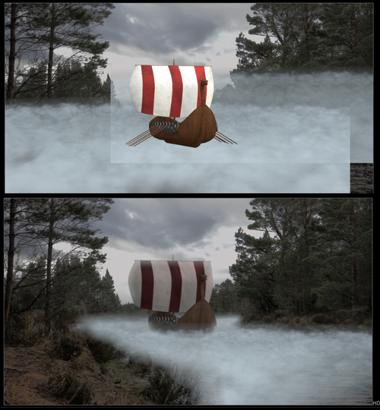

4. Keying: First I degrained and denoised the footage to get a better keying result with Keylight. To see what I did exactly I added the node tree to the picture. What you may don’t see is that I fixed the wrong lighting on the helmet and back of him. I made an animated roto which I used in the mask pipe to make it darker and less reflective.

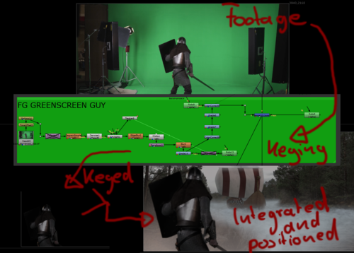

5. Integration and final grading: I also added from another green screen footage a guy on the ship in the same way I described it earlier. To have some people using the oars I used some Viking pictures, cut the heads in Photoshop and placed them behind the shields. I tracked the ship to get them the transformation they need. To get everything together and more depth into the scene I used some foreground fog and fog between the soldier in front and the ship. Finally I did some colour grading and regraining in the end.

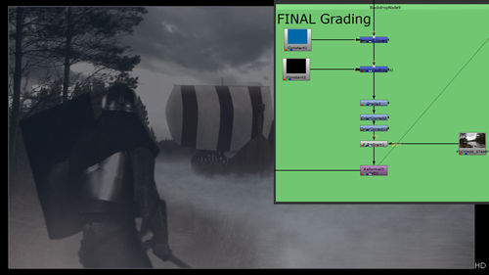

6. Final adjustments: After I rendered this as an image sequence I imported it into After Effects and made two different compositions. One with 1920x1080 and one with 1920x817 and I got the second one into the other one to have it in cinemascope. I positioned it the way I want and gave the scene a final, more interesting touch with placing a gradient from blue to something like sepia and blended it above the footage with soft light and a low transparency.

If you have any questions or tips for me to establish a better workflow I would appreciate it if you would message me!

With kind regards and thanks for reading,

Ken

[**15TH DEC 2014**](http://myjourneytovalhalla.tumblr.com/post/105345340216/making-of-the-fog)

Like I already said in an earlier post that I wasn’t able to create a realistic looking bow wave with the ship and the Maya Ocean Toolkit I decided to use more fog than I originally wanted. I didn’t want to use Stock Footage because I want to learn how I could create the exact fog I was looking for. I got my camera and ship in Maya and set an image plane again. The ship looked a bit messed up because the .fbx import wasn’t able to transfer the shaders and textures correctly but I didn’t matter because it was just for reference and the fog has no reflections so I didn’t have to deal with this problem. To see the ship not in the rendering I simply need to deactivate the “Primary Visibility” in the Attribute Editor.

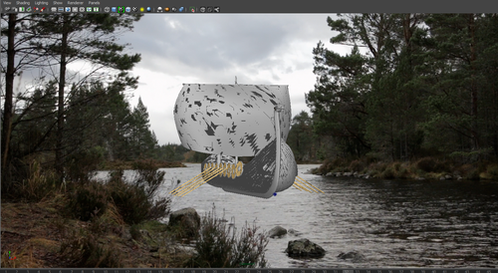

I started to look at some Ocean presets and found the “stormy ocean”. I rendered a frame and thought the fog on top of it looks a little bit like I want my fog to look. I got rid of the ocean and placed the simulation area in the correct position.

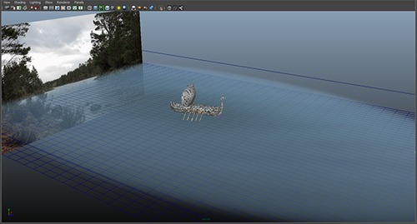

Now I needed to adjust the settings to the way I wanted to have the fog. When I rendered it the first time I could see a gradient from white to grey and ending in blue. I didn’t want the blue part so I needed to get rid of it. I also wanted some more transparency and it needed to have a higher resolution. It took a while to see which settings of the shader had which impact on my fog but finally I found everything I needed. It were those three settings which made the fog appear in the way I want it. Especially the colour part gave me the control to make the fog look fading.

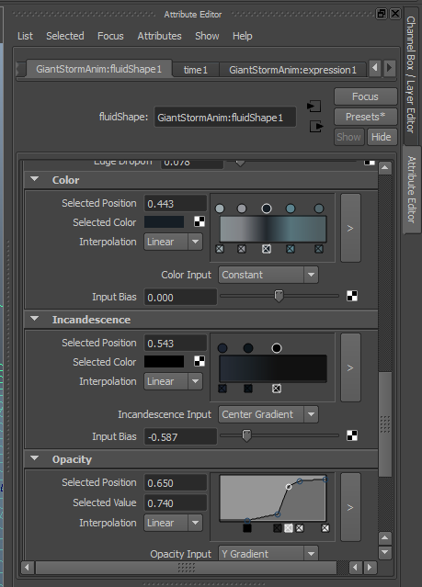

Now I needed to do some test renders again and to get the renders more faster I moved it to different machines again and started to get more into the compositing part which will be the next making of.

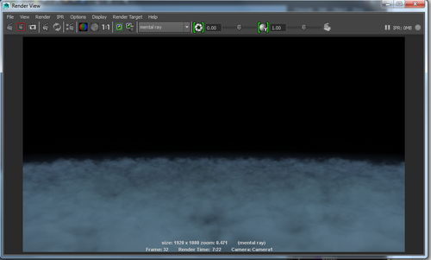

I also did another fog rendering for the foreground fog. I did it in a similar way, I used the “rolling fog” preset and moved it close to the camera and adjusted the speed, color and resolution.

Ken

[**14TH DEC 2014**](http://myjourneytovalhalla.tumblr.com/post/105344174906/making-of-the-ship)

First of all I tracked my footage to get a 3d camera of the scene I shot. I did it in Nuke with a 3d tracker, exported it as a .fbx file and imported it into 3ds Max. Since I had the camera now I just needed to add a the background plate and the first things were set up. Actually it is not necessary for the purpose of modelling but I like it when I see how my ship looks like out of the view of my ship. It is also a small trick because I was able to cheat and skip some parts which I didn’t need to model because I wouldn’t see them anyway.

Everything was set up to start modelling, I googled for long ship blueprints to have a reference of a realistic scale. After I found some I created three different planes for the front, side and top view and used the respective image for them. The following images are describing who I proceeded in modelling the ship.

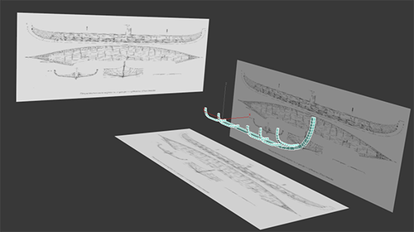

First I build those parts. It is only necessary to build one quarter of the ship because I can mirror everything else later with the mirror modifier and make slight changes to make it look different then.

When I had the base construction I started to build the shell. I used splines and connected them with the “Cross Section” tool and added a “Surface” and a “Shell” modifier to it to get faces and thickness.

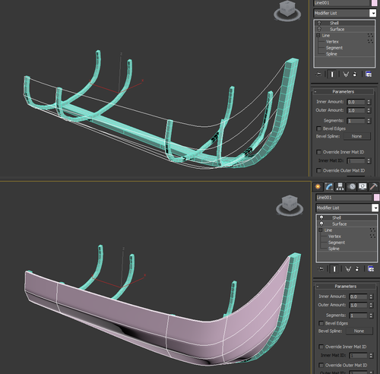

Afterwards I mirrored everything and completed the basic shape of a whole ship. Then I started to add detail on the shells of the ship to get the look of planks. I also used a shader with a high blue specular value to see the details better.

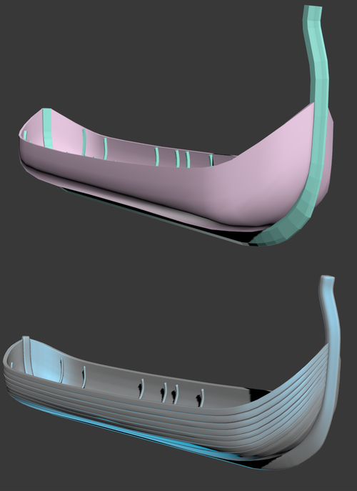

Time was running fast and I knew I had still a lot to do so I thought about which details are the most important for a longship. I looked to my reference images I collected (you can see a few of them on my moodboard earlier in the blog) and I decided I want to add those things: Oars, shields, sails and a dragon head for the part on the front of the ship.

Oars: Created with simple box modelling techniques.

Shields: Created out of a cylinder and with a few subdivisions and extrudes it was already done.

Dragon head: I visited “the free 3d model” website and searched for a fitting dragon, downloaded it, sculpted on top of it in ZBrush and imported it into my scene.

Sail: I used some splines to define the basic shape of it, created faces with the surface modifier and worked with a FreeFormDeformation modifier to get a little variation and animation into it.

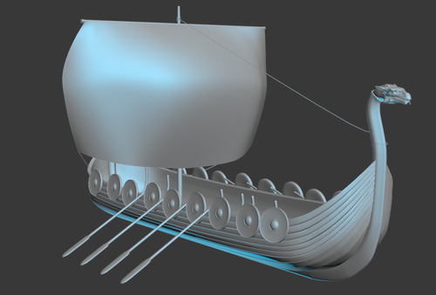

After the geometry was created I needed to texture it. The first step in texturing was creating UV maps. I created the Unwrap UV modifier and chose a fitting projection mode. If it was necessary I adjusted some things manually.

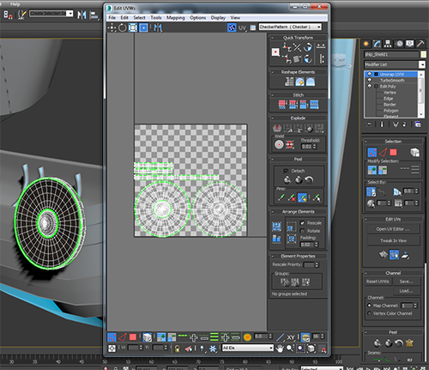

The second step after the UVs were done is creating the shaders. This was the first time I used materials from the render engine “mental ray” because in previous projects I was able to use V-Ray. I followed some tutorials on Digital Tutors and got some tips to create wood, metal and cloth material with the Arch & Design Shader.

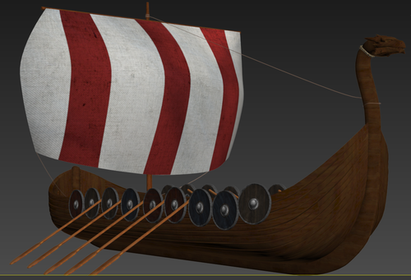

On the next picture you can see some the shaders I created.

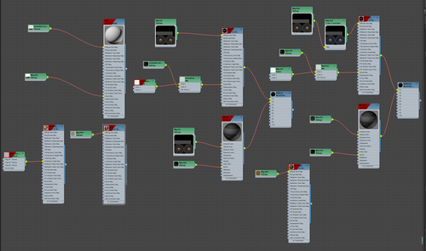

After this was done I needed to animate the ship movement. I watched some long ship-sail-competition videos on YouTube to get an idea about how they move in the water. First of all I created a helper and linked the whole ship onto it so I could move it comfortable. It was a pretty easy task to animate because basically it is just moving forward and slightly up and down because of the waves crashing into the shell. The next task was to set a proper lighting. I used a Skylight connected with an HDRi. The footage is quite cloudy with no direct sunshine and the ship needed to get lit in the same way.

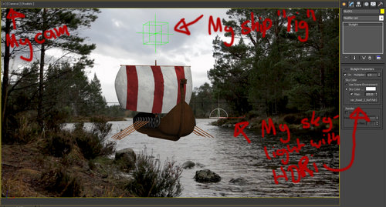

Now I did some test renders and then I moved my scene on different computers and rendered while I was already doing the next step. Simulation!

Ken

[**13TH DEC 2014**](http://myjourneytovalhalla.tumblr.com/post/105078692941/we-arrived-in-valhalla)

Yesterday night I was able to finish my shot. After several hours of roto and mistake fixing I came to a result which I am satisfied with. If I have the time for it I want to improve a few things and get more feedback to my scene. Now I will finish my work for 3D character production…

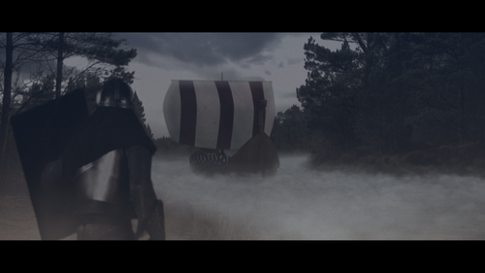

I learned a lot during this project and I am glad I took the risk and tried to do something which I was not sure about to achieve in the way I want it. In the end I learned a lot about simulation in Maya, refreshed my mind in modelling and shading in 3ds Max and improved my workflow a lot. The compositing task was nice and I enjoyed working on my scene.

Thanks for your interest,

Ken

[**12TH DEC 2014**](http://myjourneytovalhalla.tumblr.com/post/105006724766/there-are-thousand-ways-to-get-rid-of-problems-in)

After the depressing roto problem from yesterday I talked to a friend about my problem and he was able to give me a good hint how I could work around this problem because he had the problem with two Beziers in one roto node as well. As I tried it today in the morning I fixed it instantly and it was too cool because it actually worked exactly how I imagined it would after I had the talk. I also made progress in fixing other small problems and did some more integration and now I am currently test rendering.

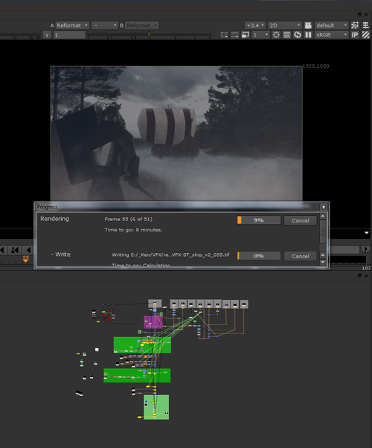

I am excited about how many things I will see which needs to get fixed. I am also looking forward to see it in cinemascope because I think it looks much more appealing with it.

Ken

[**11TH DEC 2014**](http://myjourneytovalhalla.tumblr.com/post/104938752146/compositing-is-fun)

Today I made big steps in my compositing progress. I rendered it already and checked for improvements. I have a few ideas to improve my shot but now I spent just too much time on one single problem which I couldn’t fix. I wanted to make a second roto mask to fade the fog better on the water. It is not working. I don’t know why but I will find a solution, soon. But that you have an idea, you can see it on this picture:

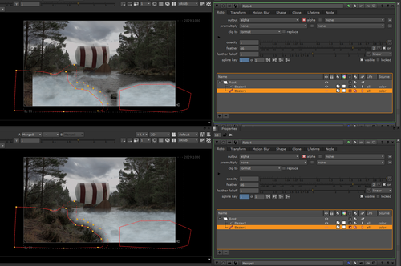

I had the left roto from the beginning, it worked fine. Now I wanted to add the one on the water to make a gradient of the opacity of the fog. I am able to have the fog IN my rotos but it is not working if I want to substract it with it… If I can fix this problem and do the other improvements my shot will be finished soon.

Ken

[**10TH DEC 2014**](http://myjourneytovalhalla.tumblr.com/post/104851673101/fog-fog-fog-and-some-compositing)

I was able to setup a satisfying fog simulation setup yesterday. I started the rendering before I left rendered it over night. When I arrived early in the morning back at my workstation it was finished and I proofed it. I found it was looking quite useable and I put it into my compositing. But this was just the layer of fog for the water. I needed another one, for the foreground that it connects everything better. I simulated on a computer next to my while I was doing compositing. I got pretty far already and since my narrative scene offers me the option to put people into my scene I added a guy in the foreground to my idea of the scene. I used green screen footage of a warrior and started to key it. I needed to fix some lighting issues and got a pretty good keying result. I also put different people onto the ship. I combined everything, did colour correction and tried to integrate the boat, the people and everything as good as I was able to. The second fog simulation was finished and then I put this layer in the foreground to cover the “seams” of the other fog. I also spent quite a long time to get the backplate color corrected in the way it needs to be for the scene. I also established the overall grading already.

On the picture:

Maya scene for the water fog and one frame of the rendering of it. On the right side there is also a small part out of the fog for the foreground I rendered.

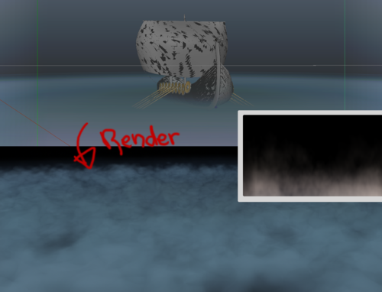

It is slowly coming together…

Ken

[**9TH DEC 2014**](http://myjourneytovalhalla.tumblr.com/post/104764727786/reason-for-simulation-problem)

The morning started with checking my renderings from the ship because when they are good a big step is already done. Somehow I didn’t include the Alpha Pass for the ship on two renders so it needed to render again for 25 fps. I split it on three computers and worked on another during this period of time. I wanted to make progress with simulating the bow waves from the ship and tried it nearly the whole day with different tutorials and forum posts but none of them leaded me to a satisfying result. One of the problem is that my scene in Maya is insanely high scaled in comparison to the one in 3ds Max. I have no clue why this happened and I tried different export options for the camera and the ship. That wasn’t the solution. I scaled in 3ds Max my ship smaller and adjusted the animation again that it looks exactly like the big one because I already rendered this and I don’t want to render again because it takes too much time. Now I worked with the smaller scene in Maya but it was still very huge.

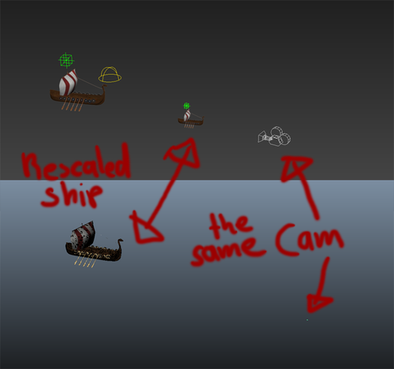

On this picture you get an idea about what I was talking about in the last sentences. I tried to use the Maya Ocean Toolkit again and finally I was able to get a working, basic wake. But I still don’t know how to adjust it the way I want it to behave. Because the deadline is coming closer I thought about an alternative solution to the bow waves. I wanted to do fog from the beginning on but now my idea is to increase the amount of fog slightly and do a more darker scene so you won’t be able to see the waves at all. This makes my scene way more atmospheric and I am excited about how my fog simulation will look like. Still a few hours today to use!

I also worked already in my Nuke scene and I set up the Multipass Compositing and did the first color matching of the ship to my backplate.

Ken

[**8TH DEC 2014**](http://myjourneytovalhalla.tumblr.com/post/104684989876/texturing-and-simulation-problems)

I started early in the morning doing UV’s for the whole ship. After this step was done I could texture them in Photoshop and start learning about the mental ray shaders. Originally I wanted to shade and texture the ship in Maya but it would have been too time consuming to learn everything completely new and that’s the reason I decided to go for it in 3ds Max. Since I have never worked there with mental ray as well I learned at least something new in Max. I tried to export the ship with the shaders to Maya after I was finished but they were totally messed up. I definitely knew now I need to render in 3ds Max. I animated the ship movement and the sail, did a HDRI lighting setup and did a few test renders.

This is a viewport capture of the textured ship:

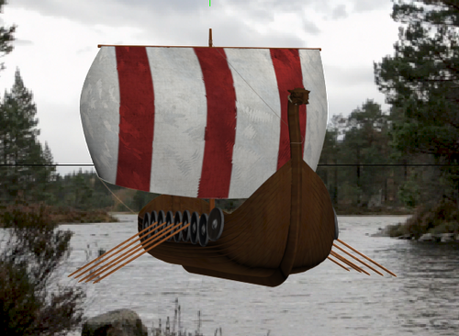

I started to render on two computers next to my work station because D35, the room I am working in, is nearly empty. Now I needed to focus on the water simulation. I watched the tutorial about Bifrost and tried to do it as well. I had big problems with setting up the simulation because the computers here don’t have enough memory to make a simulation like this. Now I need to think about another solution to get bow waves… Hopefully I’ll find one soon… Time is running.

Ken

[**7TH DEC 2014**](http://myjourneytovalhalla.tumblr.com/post/104597717921/the-ship-is-in-progress)

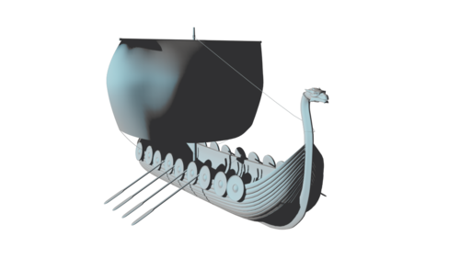

I spent my weekend on refreshing my modelling skills and did my best on the ship. Because the deadline is coming closer and closer and I don’t know what problems I will face with the simulation part I skipped the parts you won’t see in the scene.

Now I need a small break until tomorrow early in the morning when I want to start texturing and shading the ship.

[**6TH DEC 2014**](http://myjourneytovalhalla.tumblr.com/post/104501161846/my-concept-makes-me-face-new-challenges)

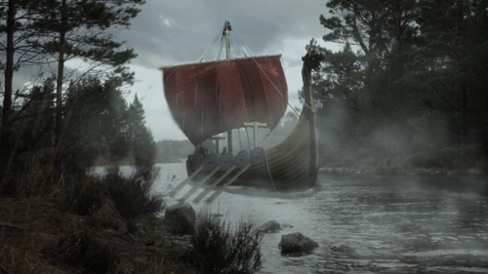

This is my concept for the scene, out of the book, I want to create. In the first post you saw how the original footage looks like and if you compare it you can see the amount of work I need to do. To get a good overview of what needs to get done I ask myself a few questions.

What assets do I need to create?

- I need to model, shade and render the Viking ship

- I need to simulate the bow wave the ship makes

- I need to simulate the fog which the ship appears out

What do I need to deal with?

- I need to refresh my skills in 3d modelling

- I need to learn to shade and render with mental ray in Maya since I only used V-Ray and 3ds Max. (Why not render again in Max? I want to learn something new and I think the rendering pipeline with mental ray Maya is more useful than in 3ds Max)

- I need to learn how to use Bifrost and the Maya Ocean Toolkit to simulate the bow waves. I have to do this as well for the fog.

Is there a way to get help?

- There is! I searched for hours different tutorials which could help me to achieve my goals and I made a text file with the hyperlinks in it.

Ship Modeling:

[**http://www.digitaltutors.com/tutorial/800-Modeling-a-Detailed-Ship-in-Maya**](http://www.digitaltutors.com/tutorial/800-Modeling-a-Detailed-Ship-in-Maya)

Though it is a tutorial for Maya it can help me to refresh my mind for some parts of the ship.

Ship rendering and shading:

[**http://www.digitaltutors.com/tutorial/3575-Render-Passes-in-Maya**](http://www.digitaltutors.com/tutorial/3575-Render-Passes-in-Maya)

[**http://www.digitaltutors.com/tutorial/132-mental-ray-Rendering-Tips-for-Maya**](http://www.digitaltutors.com/tutorial/132-mental-ray-Rendering-Tips-for-Maya)

[**https://www.youtube.com/watch?v=LR00i6u2ueI**](https://www.youtube.com/watch?v=LR00i6u2ueI)

[**http://tutorials.cgrecord.net/2012/11/creating-realistic-wood-material-part13.html**](http://tutorials.cgrecord.net/2012/11/creating-realistic-wood-material-part13.html)

Bifrost simulation for bow wave:

[**http://www.youtube.com/watch?v=xB33VVVsHoI**](http://www.youtube.com/watch?v=xB33VVVsHoI)

Ocean simulation:

[**http://www.youtube.com/watch?v=7huBJq_YcSs**](http://www.youtube.com/watch?v=7huBJq_YcSs)

Fog simulation:

[**https://www.youtube.com/watch?v=9sPeFAe1az0**](https://www.youtube.com/watch?v=9sPeFAe1az0)

There is a lot of work to do for me in the next 11 days until I need to hand in the assignment but I am really looking forward to do this, learn new things and give me a good challenge… The next blog entries will be about my progress in modelling the Viking ship.

Ken

[**5TH DEC 2014**](http://myjourneytovalhalla.tumblr.com/post/104403845946/getting-inspiration-by-references)

Since my first blog entry I started to think intensely about how my scene, especially the ship should look like and I watched some short parts out of Viking documentations and searched for references. After I collected a lot of them, I sorted them out again to get a more specific look I want to achieve. I created a moodboard out of the ship, fog & shield (for the ship) references I liked and which inspired me the most.

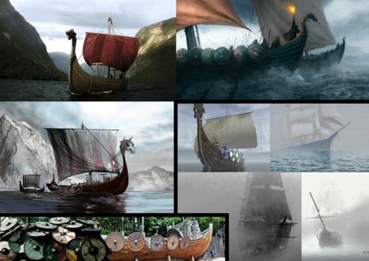

My next post will be my specific concept for the scene…

Ken

[**28TH NOV 2014**](http://myjourneytovalhalla.tumblr.com/post/103799942836/welcome-to-my-journey-to-valhalla)

I am Ken, a German exchange student at the Napier University in Edinburgh until the end of December. I chose the Napier University because they offered modules where I am able to learn new skills in 3D character production and visual effects.

This blog is about the emergence of my second coursework for the module ‘Visual Effects Storytelling’ which I am attending. I have been tasked to create a visual effects shot that effectively visualises part of a defined written narrative. I will tell you about my ideas, the problems I need to face & my progress until the finished shot.

I started thinking about an idea for the second coursework soon because I knew the faster I have the idea, the faster I can start the research. While I was still busy with the first coursework I went to the city Aviemore with other students to do a mountain biking trip to discover something from Scotland. Because we knew the landscape would be really beautiful there a friend of mine took his DSLR camera with him that we would be able to shoot some footage for the second coursework. While we were crossing a small bridge above a river I saw an awesome headland where I instantly had the thought “I want to film this, build a Viking ship in 3D and composite it into this wonderful view”. I think I had this idea because I really loved watching the “Vikings” TV Series which I recently finished.

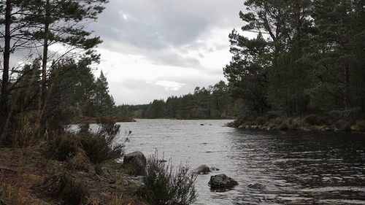

The first step to take was finding a fitting piece of narrative for my idea but I postponed this task until I finished my first coursework.

Now it is finished and I started to search for a book which was not the easiest task. After spending hours of looking inside different Viking novels on Amazon I did a small break and went to YouTube and watched some VFX breakdowns. One of them was from the most recent season of “Game of Thrones” and I remembered the gorgeous ending scene of the last episode and thought: “Okay, I could definitely try to do this as well!”

( SPOILER: [**http://www.youtube.com/watch?v=Ut1VEoOZ2hA**](http://www.youtube.com/watch?v=Ut1VEoOZ2hA) )

I asked a friend of mine who read all the books where I can find this scene. After I found it I got a little demotivated because it is not well described in the book and it ends after the “Valar Morghulis” dialogue. Well, the “ship sailing away” scene was free interpreted by the producers of the TV series. I had to continue the search…

A few days later I finally found a very nice scene in the book “The Long Ships” by Frans G. Bengtsson: “Suddenly, they heard ahead of them the clank of rowlocks and the plash of oar-blades dipping evenly, and out of the haze appeared a single long ship approaching round a headland. It made towards them, without slackening its stroke, and they all stared at it, for it was large and splendid to behold, with a red dragon-head at its prow, and twenty four pairs of oars and they were glad that it was unaccompanied.”

Now I need to make a brief concept about my scene and continue my research about the techniques I need to acquire to produce this shot, the problems I may face and setup a time schedule because I also need to continue working on courseworks for other modules (e.g. producing a 3D character).

I hope you will find my journey interesting and it keeps you on following my blog,

Ken